

We are a conversion optimization agency focused on A/B testing. Each of our developers works with a few clients that come from different business sectors and have different technical needs. Our job is not a conventional front-end development one, as we need to make changes without having access to the website's code. Each test is different, and we regularly have worthwhile challenges. Our best friends are Mr. Reverse Engineering, Miss "I shall hack my way in!" and Dr Creative Thinking.

A/B testing is a method of comparing two versions of a webpage against each other and using tracked analytical data to determine which one performs better. In order to create a version of the webpage with our changes, we write CSS, HTML and JavaScript code that we inject into the page.

To create an A/B test we usually use Optimizely platform, as well as its statistical engine to grind the analytical data.

**Conversion.com’s**

Frontend Developer Test

Still curious about A/B testing? Read this​ .​

But today, you will be working in a much more simplified way. With the exception of Task #1, what we ask of you is to **write code that you paste into the browser's console**​ and it solves the given​ task. Including HTML and CSS where necessary. Please use pure JavaScript or jQuery only.

If you have any questions about the test, please email grace.aldridge@conversion.com​ . All answers​ must be delivered via a .zip file or alternatively using a code hosted service such as https://jsfiddle.net/.​

# Question 1​

Download our PSD here​ (if you don’t have Photoshop, you can use our Figma ​ alternative​ )​ and create a page which contains the content of the lightbox.

* Create it in a <div> element with id “cv-lightbox”.

* The countdown at the top should start at 2 minutes (2:00) and countdown each second until 0:00. It should then continue to show 0:00.
* Ensure that it displays correctly in IE11 and above.

# Question 2​

Go to: http://conversion.com/contact/​ .​

Give the code that, once pasted into the browser’s console, will display an alert box containing the value of the selected radio button whenever a user selects a radio button.

# Question 3​

Go to: https://register.ft.com/​ .​

Give the code that, once pasted into the browser’s console, will merge the first name and last name fields into one field called "Name" and **still allows the form to validate correctly**​ . This will change​ the fields from this looking like this:

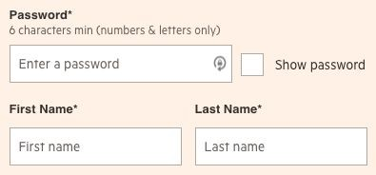

To looking like this:

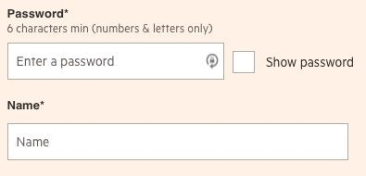

# Question 4​

PLEASE NOTE: We don’t require full code for question 4. Instead, provide enough code/context to explain how you would solve this, and deal with any issues.

Go to: http://www.whoishostingthis.com/compare/​ .​

Change this page so that the second host (in this case, Innovation Hosting) is discounted by 10% and the price per month is highlighted in red.

Your code should be able to run on page load and produce the expected result. Using any of the filters on the left-hand side of the page should also work. For example, if a user ticks “Unlimited Bandwidth” and “Free Domain”, the second result should be discounted by 10% and shown in red.

Please provide an outline of the code and how you would approach modifying the calculator’s output to discount this price by 10%, and change the formatting, to make it look like this:

